**Plug-in Wizard Overview**

**Maya Overview**

**Assignments**

**HelloWorld Project**

* **Topics Covered**
  + Create a Maya plug-in project
  + Implement the very basic skeleton “helloWorld” project
* **Overview**

In this exercise, we will learn how to create a very basic skeleton helloWorld plug-in.

* **Exercises**

1. Launch Visual Studio 2005
2. Create a new Visual Studio project

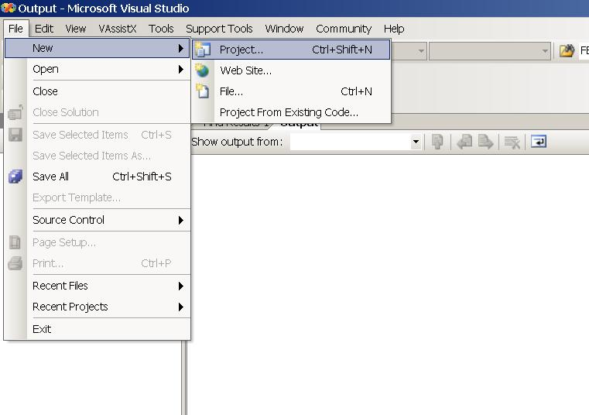

1. Set the following:
   1. Project type: MayaPluginWizard
   2. Project Name: helloWorld
   3. Location: C:\MayaAPITraining\helloWorld\Exercise
   4. Deselect “Create directory for solution”

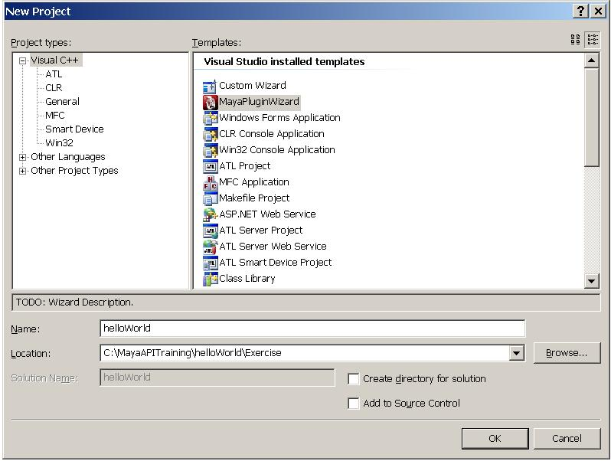

1. When the Maya Plug-in Wizard appears, you may encounter a security warning, click on ‘Allow Blocked Content’.

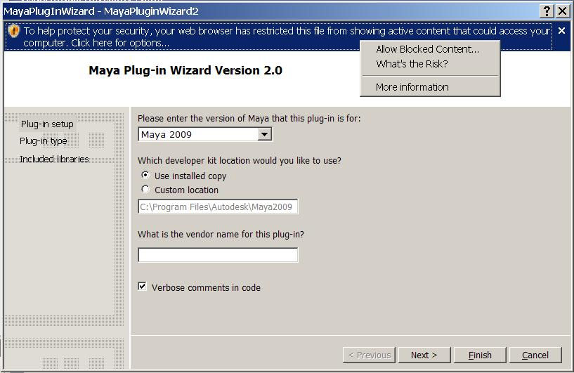

1. Notice you are now in “plug-in setup” step, click on “Next”,

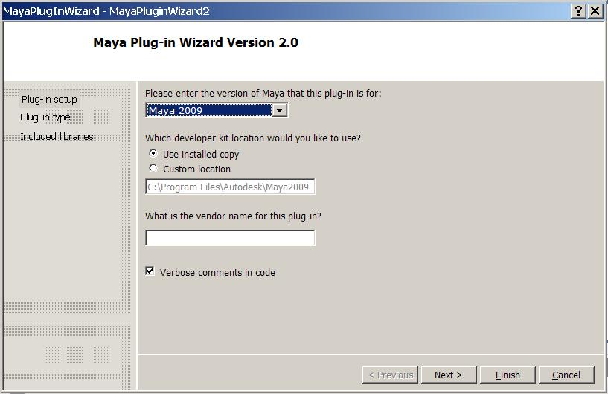

1. Notice now you are in “plug-in type” step, set the following and click on “Next”
   1. Plug-in Type: Empty
   2. Plug-in Name: helloWorld

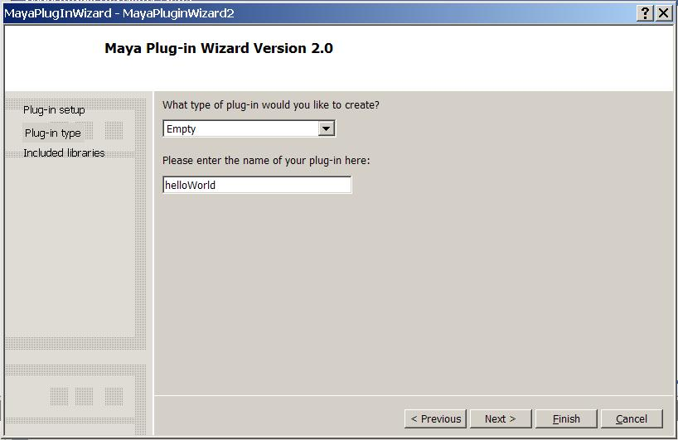

1. You are now in “Included libraries” step, use the default library selection and click on “Finish”

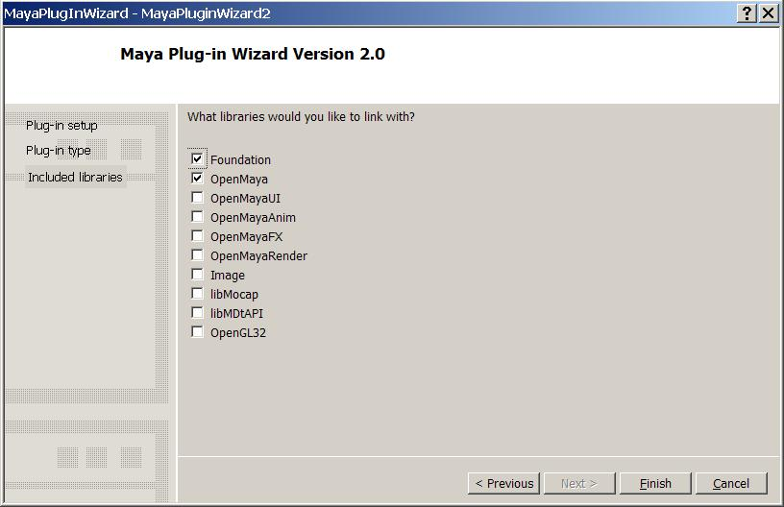

1. Go to initializePlugin() function, type in

cout<<"This is my hello world project! "<<endl;

Save the modification.

1. Congratulations, you’ve created your first “helloWorld” Maya plug-in project
2. One final adjustment to the project:
   1. Under ‘Project > helloWorld Properties’
   2. Select ‘Configuration Properties > Linker > General’ from the left pane.
   3. Change ‘Output File’ to:

../../../plug-ins/helloWorld.mll

* 1. This will redirect the plug-in to be placed in the C:\MayaAPITraining\plug-ins\ folder.

1. Now build the project by clicking on “Build”> “Build Solution”
2. In Maya, load the plug-in and the print out message will appear in the Maya output window.